# Project Specification

|  |  |
| --- | --- |
| Project Title | History based Visual Novel Game |
| Student | Sayma Begum 33565774 |
| Supervisor | Dr Ida Pu |

## Work Overview:

My idea is to create a historical visual novel game. The game is for secondary and college/sixth form school students who are learning about the Russian Revolution in school. I think games are a good way to learn as it is an interactive experience for both student and teacher (Noonoo, 2019). I’ve read through some of the history curriculum written by the department of Education to pick a period in history so it would be well catered for their education. (Department of Education, 2013) Therefore, I have come to the conclusion in the game you will act as a solider trying to survive in 19th century Russia. Features in the game will include: Choice based role play, mini games, several game paths, and inventory and stat system.

## Technologies and Materials:

### Languages:

I'm planning to use a game engine called Renpy, which is a popular option for creating visual novel games. The engine itself uses their own language called Renpy which is based on Python and Cython (a mixture of python and C) (Renpy, 2004).

As well as coding the game, I am also going to code my own music using a coding language called Sonic Pi. Sonic pi is a language created by Dr Sam Aaron which helps to get people into computing. The language is primarily based in Ruby and is written on a ruby file unlike Renpy which is written in its own file called a .rpy file. The language allows you to code your own music using a plethora of instruments. (Aaron, 2012)

For some scenes in the game I am also planning to use some images made from P.5 JS, this will be generative drawings which will be used as the background in some parts of the game.

### Physical Equipment:

The main physical equipment which will be needed is a graphics tablet. This will help me style my game. A graphics tablet can be used to draw mainly artwork such as Game characters, backgrounds, and the Graphical User Interface(GUI). I already own a graphics tablet so there will be no problem with retrieving it.

### Other Equipment:

Renpy Game Engine - I will use this in the development stage to code for the visual novel.

Sonic Pi Software -This is needed to code in Sonic Pi.

Autodesk Maya – I will use this software to animate some scenes in the game and to model some 3d game assets.

### Techniques:

A number of techniques will need to be used for this project.

* Audio programming- Using Sonic Pi for the Music.
* Generative Drawing- Creating background art in the game.
* 3D modelling & Animation- Creating Game assets
* 2D collision detection for mini games.

### Libraries & Frameworks:

* I will use p5.JS which is a JavaScript library, it is mostly used for creative projects.

(p5.js, 2008)

## Motivational Research:

I’ve always had an interest in History. I saw a YouTube video on the Russian Revolution which was created in such a fun and entertaining way. This is what sparked the idea of creating a history game for teens. I already knew many people who did Alevel in History and were taught ‘Tsarist Russia’ and the revolution in school and to my amazement they had found it extremely boring. (OverSimplified, 2020).

### Questionnaire:

I’ve also created a questionnaire researching trends amongst games and education.

When questioned why they did not like their lessons:

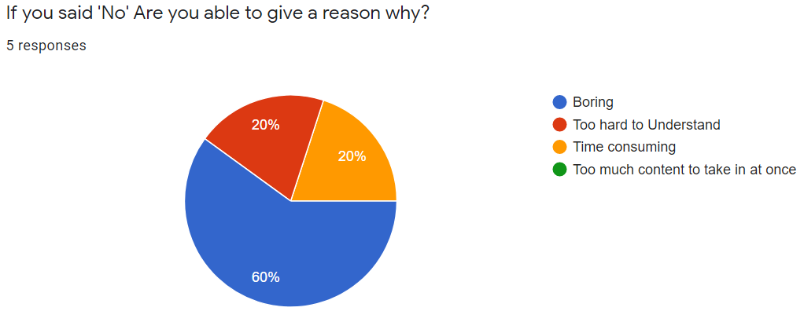

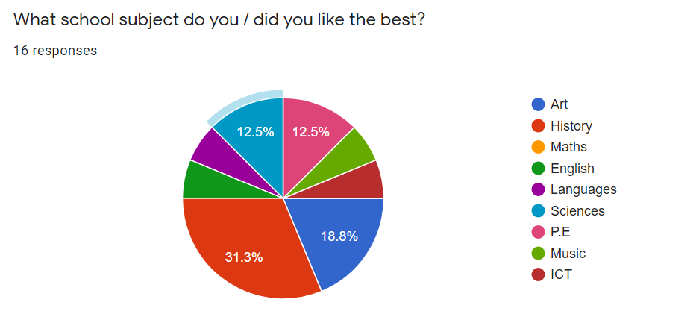

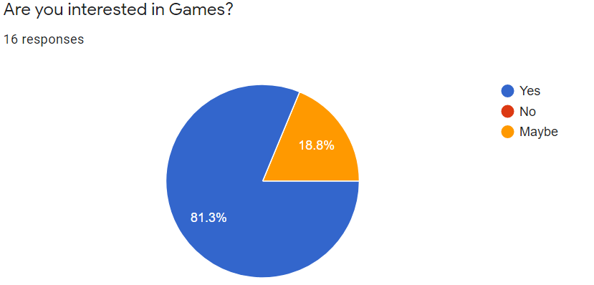

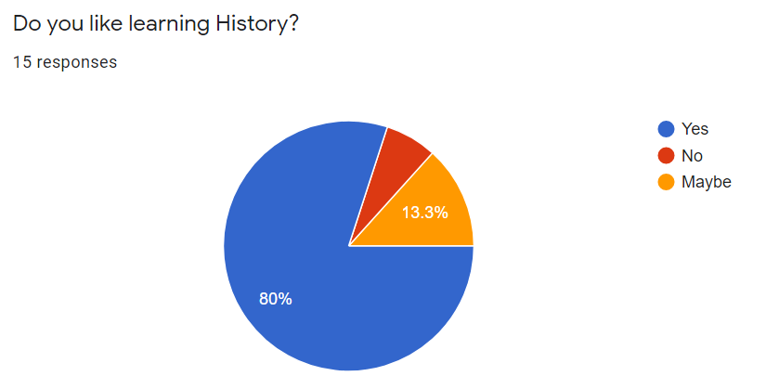

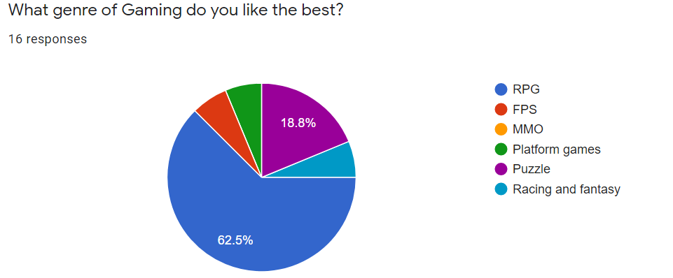

Many participants stated they find their lessons boring, I think my game will help a lot of students to learn in a really interesting way.

Around 31% also said History was their favourite subject, so this means my project will naturally draw in many students just by the historical genre alone.

These pin point why this game is needed amongst students. 80% of students have said they like learning about History, 80% also said they like games. I think this a clear sign that a historical game would be perfect to create.

62.5% Also said Role playing games were their favourite type of game. This is also aligned well with my project.

### Similar applications:

There actually isn’t a lot of extremely similar games out there in the visual novel community. Many visual novel games tend to favour the fantasy and romance genres. However, I will list visual novel games that I’m taking inspiration from.

* Therapy with Dr. Albert Krueger - (dino999z, 2020)
* STEINS; GATE Steam Trailer- (MAGES., 2016)

## Existing Knowledge:

This project will include knowledge which I attained from past and current modules at University.

In my first year of University I did a module called ‘Introduction to Programming.’ This taught me the basics of programming and a lot of fundamentals about coding which could be transferred to any language. We also coded in p5.js which is the language I will be using for some of the project.

I am currently doing a module called ‘Introduction to Modelling and Animation,’ this module was taught with a software called Autodesk Maya. I now know how to model and animate 3d objects. This will be very useful for when I animate scenes in the game.

Interaction design is also a module I am doing this year, this is all about UX design and how to design a good interface. I will use this knowledge to help me design the buttons and other GUI in the game.

## New knowledge:

Although I have some experience working with the game engine, coding complex mini games in Python will be a new challenge for me as I will have to do more research in the coding language. However, I’ve seen some tutorials for this online. There is also extensive documentation on their website. (Elaine, 2017), (Renpy, 2004a).

Sonic pi is a completely new coding language which I will have to get to grips with too to code the music for the game. However, there is a lot of documentation on the Sonic Pi website and I have taken a look at the software itself and found it quite easy to experiment with. (Aaron, 2012)

## Timelines & Milestones:

|  |  |
| --- | --- |
| **Milestones** | **Dates** |
| Research for the Game | 01/11/2020-05/11/2020 |
| Art/asset creation | 04/11/2020-12/11/2020 |
| Game script writing | 06/11/2020-05/12/2020 |
| Basic prototype / base Template(no mini games just story line) | 05/12/2020-20/02/2020 |
| Interim Report | 12/12/2020-11/01/2021 |
| Coding Mini games for the game (mostly will be puzzle games) | 20/02/2021-10/03/2021 |
| Coding background music | 05/12/2021-20/03/2021 |
| Testing | 12/03/2021-05/04/2021 |
| Submit draft report | 01/03/2021-26/03/2021 |
| Bug Fixing | 12/04/2021-05/05/2021 |
| Final Report | 12/03/2021-14/05/2021 |

## Include contingency planning:

If issues arise in the game, then the minimum product I will deliver will be:

* A game which allows includes choice selection, each choice will have an effect on the outcome of the game.
* A game which has background music, made with Sonic pi.
* Backgrounds to the game will be all complete, some of them will be made using P5.js.
* User sprites and art work will be all completed.
* There will be at least one mini game which can be played.
* A very simple inventory system is implemented in the game.

## Gantt Chart:

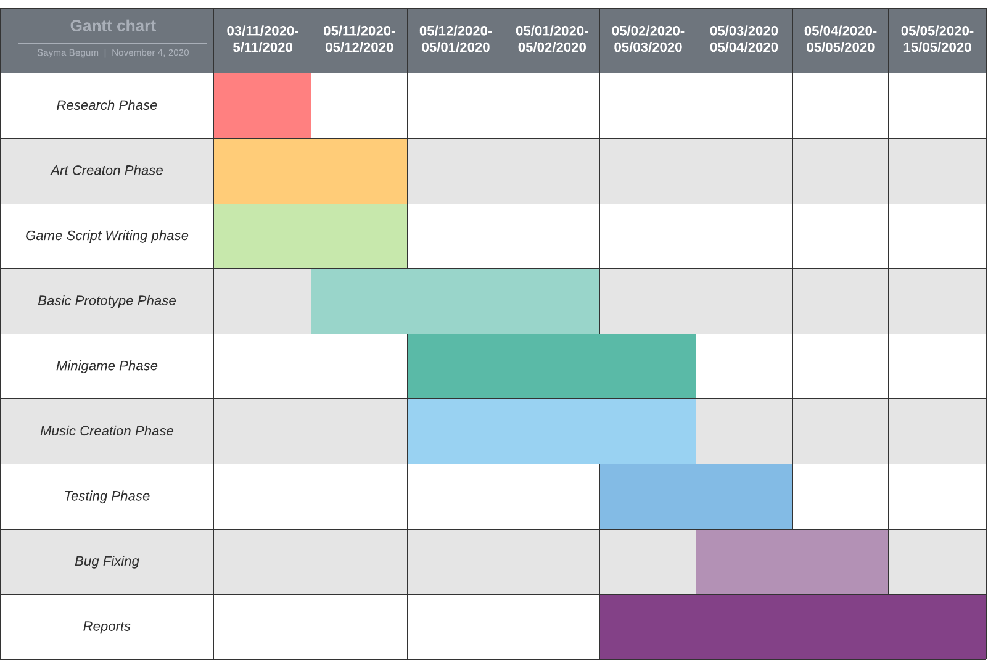

## References:

* Noonoo, S. (2019, February 12). *Playing Games Can Build 21st-Century Skills. Research Explains How.* EdSurge. <https://www.edsurge.com/news/2019-02-12-playing-games-can-build-21st-century-skills-research-explains-how>
* Department of Education. (2013). *History programmes of study: key stage 3*. Gov.Uk. <https://assets.publishing.service.gov.uk/government/uploads/system/uploads/attachment_data/file/239075/SECONDARY_national_curriculum_-_History.pdf>
* Renpy. (2004, August 24). *The Ren’Py Visual Novel Engine*. What Is Ren’Py? <https://www.renpy.org/>
* Aaron, D. S. (2012). Sonic Pi - The Live Coding Music Synth for Everyone. Sonic Pi. <https://sonic-pi.net/>
* Elaine. (2017, November 18). *Renpy Tutorial: RPG Inventory Part 1*. YouTube. <https://www.youtube.com/watch?v=leEiOzuVpTc&t=1031s>
* Renpy. (2004a, August 24). *Screens and Screen Language — Ren’Py Documentation*. <https://www.renpy.org/doc/html/screens.html>
* OverSimplified. (2020, August 17). *The Russian Revolution - OverSimplified (Part 1)*. YouTube. <https://www.youtube.com/watch?v=Cqbleas1mmo>
* dino999z. (2020, September 22). *Therapy with Dr. Albert Krueger - Launch Trailer*. YouTube. <https://www.youtube.com/watch?v=30B7fGbe7d8&feature=emb_title>
* MAGES. (2016, September 9). *STEINS; GATE Steam Trailer*. YouTube. <https://www.youtube.com/watch?v=dS3Y0TqEnnc>
* p5.js. (2008). *home | p5.js*. <https://p5js.org/>